HPCL Assignment_1

Name: Shashank Shenoy

PRN: 22510013

Batch: B5

**Title**: Introduction to OpenMP

Problem Statement 1 – Demonstrate Installation and Running of OpenMP code in C

Steps Performed:

1. Visited official website of minGw and installed the compiler
2. Selected packages needed for parallel programming i.e mingw32-pthreads-w32

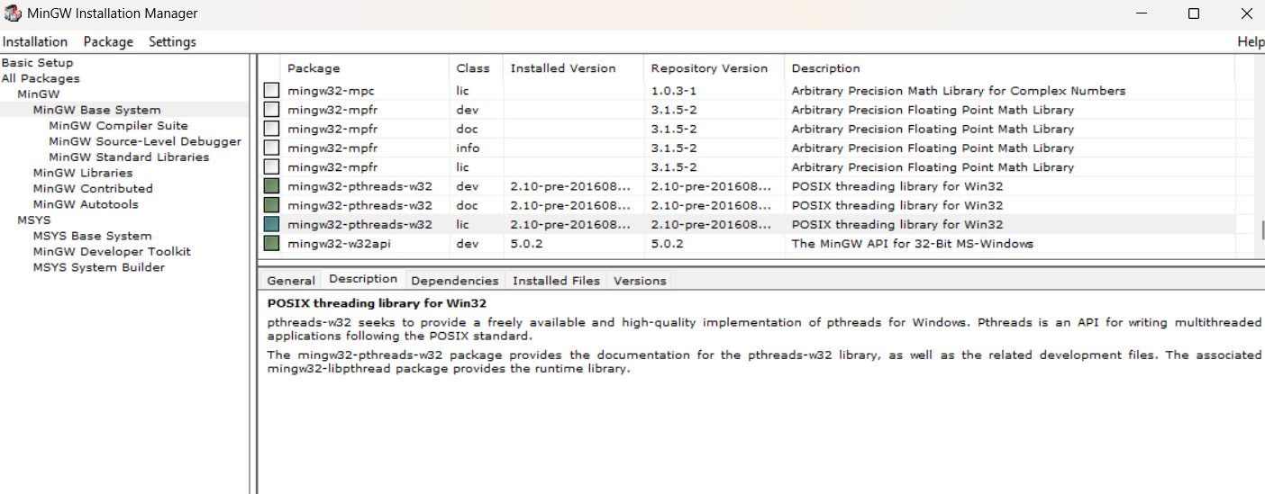

1. Run a program to test

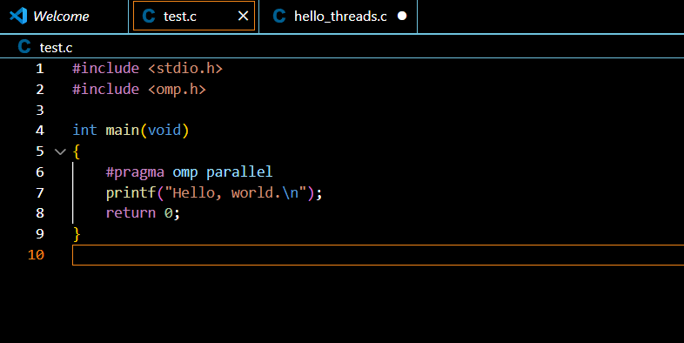

Output:

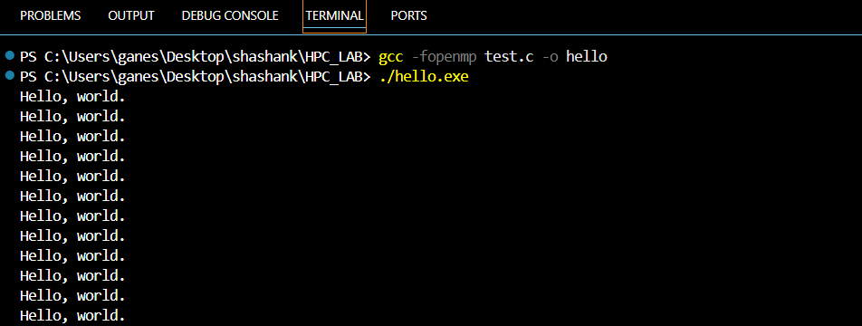

Problem Statement 2 – Print ‘Hello, World’ in Sequential and Parallel in OpenMP

Code Snapshot :

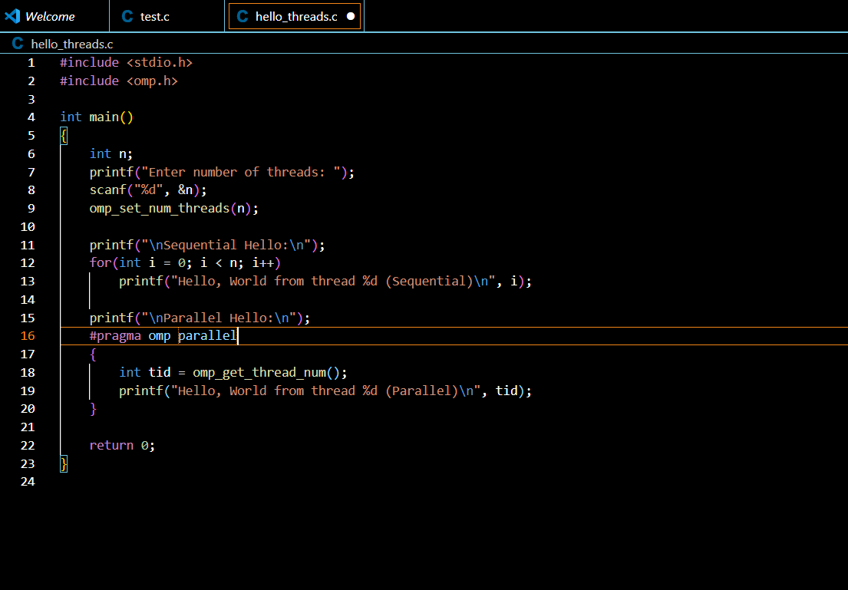

Output:

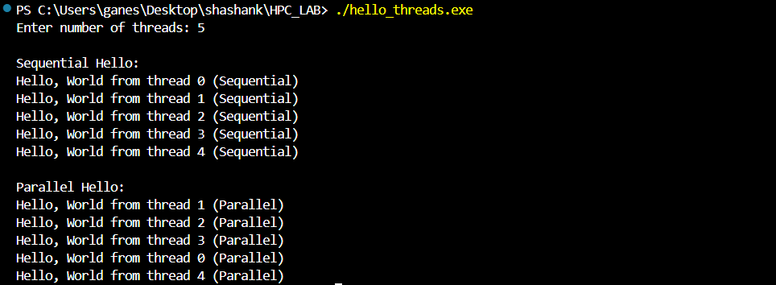

Analysis :

In sequential program the code is executed line by line and in order on a single core ,whereas on parallel program each thread gets unique id and gets executed concurrently and hence has different order of execution

**Problem statement 3**: Calculate theoretical FLOPS of your system on which you are running the above codes.

CPU: AMD Ryzen 5 5625U with Radeon Graphics

Number of Cores: 6

Clock Speed: 2.301 GHz

FLOP per Cycle: 8 (assumed)

Calculation :

FLOPS = 6 × 2.301 × 10^9 × 8

= 110.448 × 10^9

= 110.45 GFLOPS